**Task#1:** Create an application which has the following activities:

1. ***MainActivity***

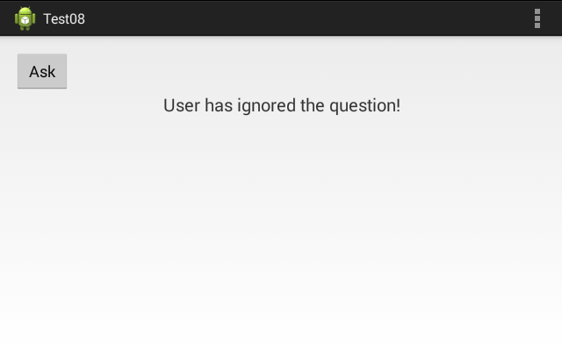

1. ***AskActivity***

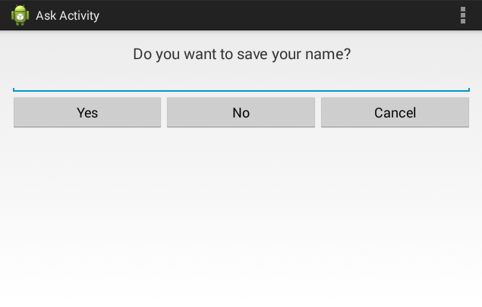

**Solution:**

**XML:**

**(Main)**

<?xml version="1.0" encoding="utf-8"?>  
<RelativeLayout xmlns:android="http://schemas.android.com/apk/res/android"  
  
 xmlns:tools="http://schemas.android.com/tools"  
 android:layout_width="match_parent"  
 android:layout_height="match_parent"  
 tools:context=".MainActivity">  
  
 <LinearLayout  
 android:layout_width="match_parent"  
 android:layout_height="match_parent"  
 android:weightSum="10"  
 android:orientation="vertical">  
   
 <TextView  
 android:id="@+id/title_text_view"  
 android:layout_width="match_parent"  
 android:layout_height="wrap_content"  
 android:text="Ask"  
 android:textSize="40dp"  
 android:textAppearance="?android:textAppearanceLarge"  
 android:textStyle="bold"  
 android:textAlignment="center"/>  
 <TextView  
 android:layout_width="match_parent"  
 android:layout_height="wrap_content"  
 android:layout_weight="0.5"  
 android:text="(Activity Communication)"  
 android:textAlignment="center"  
 android:textSize="20dp"/>  
 <TextView  
 android:layout_width="match_parent"  
 android:layout_height="wrap_content"  
 android:layout_weight="2"/>  
  
  
 <Button  
 android:id="@+id/btnAsk"  
 android:layout_width="wrap_content"  
 android:layout_height="wrap_content"  
 android:textAlignment="center"  
 android:layout_gravity="center"  
 android:textSize="20dp"  
 android:onClick="movepage"  
 android:text="Ask" />  
  
 <TextView  
 android:layout_width="match_parent"  
 android:layout_height="wrap_content"  
 android:layout_weight="0.5"  
 android:text="User has ignored the Question!"  
 android:textAlignment="center"  
 android:textSize="20dp"/>  
  
 <TextView  
  
 android:layout_width="match_parent"  
 android:layout_height="wrap_content"  
 android:text="Khizar Hayat"  
 android:textSize="20dp"  
 android:textAppearance="?android:textAppearanceLarge"  
 android:textStyle="bold"  
 android:gravity="center"  
 android:textAlignment="center"  
 android:layout_weight="4"/>  
   
 </LinearLayout>  
  
</RelativeLayout>

**(Ask)**

<?xml version="1.0" encoding="utf-8"?>  
<RelativeLayout xmlns:android="http://schemas.android.com/apk/res/android"  
  
 xmlns:tools="http://schemas.android.com/tools"  
 android:layout_width="match_parent"  
 android:layout_height="match_parent"  
 tools:context=".MainActivity">  
  
 <LinearLayout  
 android:layout_width="match_parent"  
 android:layout_height="match_parent"  
 android:weightSum="10"  
 android:orientation="vertical">  
  
 <TextView  
 android:id="@+id/title_text_view"  
 android:layout_width="match_parent"  
 android:layout_height="wrap_content"  
 android:text="Ask"  
 android:textSize="40dp"  
 android:textAppearance="?android:textAppearanceLarge"  
 android:textStyle="bold"  
 android:textAlignment="center"/>  
 <TextView  
 android:layout_width="match_parent"  
 android:layout_height="wrap_content"  
 android:layout_weight="0.5"  
 android:text="(Activity Communication)"  
 android:textAlignment="center"  
 android:textSize="20dp"/>  
 <TextView  
 android:layout_width="match_parent"  
 android:layout_height="wrap_content"  
 android:layout_weight="2"  
 android:id="@+id/textResult"  
 android:textSize="40dp"  
 android:textAppearance="?android:textAppearanceLarge"  
 android:textStyle="bold"  
 android:textAlignment="center"/>  
  
  
 <TextView  
 android:layout_width="match_parent"  
 android:layout_height="wrap_content"  
 android:layout_weight="0.5"  
 android:text="Do you want to save your name?"  
 android:textAlignment="center"  
 android:textSize="20dp"/>  
  
 <EditText  
 android:layout_width="match_parent"  
 android:layout_height="wrap_content"  
 android:layout_weight="0.5"  
 android:id="@+id/textInput"  
 android:hint="Enter your Name"/>  
  
 <LinearLayout  
 android:layout_width="match_parent"  
 android:layout_height="wrap_content"  
 android:orientation="horizontal"  
 android:weightSum="3"  
 android:layout_weight="0.5">  
 <Button  
 android:id="@+id/btnYes"  
 android:layout_width="wrap_content"  
 android:layout_height="wrap_content"  
 android:textAlignment="center"  
 android:layout_gravity="center"  
 android:textSize="20dp"  
 android:text="Yes"  
 android:onClick="optionYes"  
 android:layout_weight="1"  
 android:textAllCaps="false"/>  
 <Button  
 android:id="@+id/btnNo"  
 android:layout_width="wrap_content"  
 android:layout_height="wrap_content"  
 android:textAlignment="center"  
 android:layout_gravity="center"  
 android:textSize="20dp"  
 android:text="No"  
 android:onClick="optionNo"  
 android:layout_weight="1"  
 android:textAllCaps="false"/>  
 <Button  
 android:id="@+id/btnCancel"  
 android:layout_width="wrap_content"  
 android:layout_height="wrap_content"  
 android:textAlignment="center"  
 android:layout_gravity="center"  
 android:textSize="20dp"  
 android:text="Cancel"  
 android:onClick="optionCancel"  
 android:layout_weight="1"  
 android:textAllCaps="false"/>  
 </LinearLayout>  
  
 <TextView  
  
 android:layout_width="match_parent"  
 android:layout_height="wrap_content"  
 android:text="Khizar Hayat"  
 android:textSize="20dp"  
 android:textAppearance="?android:textAppearanceLarge"  
 android:textStyle="bold"  
 android:gravity="center"  
 android:textAlignment="center"  
 android:layout_weight="4"/>  
   
 </LinearLayout>  
  
</RelativeLayout>

**JAVA:**

**(Main)**

public class MainActivity extends AppCompatActivity {  
  
 Button btn;  
  
 @Override  
 protected void onCreate(Bundle savedInstanceState) {  
 super.onCreate(savedInstanceState);  
 setContentView(R.layout.activity_main);  
  
 btn= findViewById(R.id.btnAsk);  
 }  
  
 public void movepage(View v)  
 {  
 Intent in = new Intent(MainActivity.this,Ask.class);  
 startActivity(in);  
 }  
}

**(Ask)**

public class Ask extends AppCompatActivity {  
  
 Button btnYes,btnNo,btnCancel;  
 EditText input;  
 TextView output;  
 String data;  
  
 @Override  
 protected void onCreate(Bundle savedInstanceState) {  
 super.onCreate(savedInstanceState);  
 setContentView(R.layout.activity_ask);  
   
 btnYes = (Button)findViewById(R.id.btnYes);  
 btnNo = (Button)findViewById(R.id.btnNo);  
 btnCancel = (Button)findViewById(R.id.btnCancel);  
 output = (TextView)findViewById(R.id.textResult);  
 input = (EditText) findViewById(R.id.textInput);  
 }  
   
 public void optionYes(View v)  
 {  
 data = input.getText().toString();  
 output.setText(data);  
 Toast.makeText(getBaseContext(),"Name saved.",Toast.LENGTH_SHORT).show();  
 }  
 public void optionNo(View v)  
 {  
 output.setText("");  
 Toast.makeText(getBaseContext(),"Name not saved.",Toast.LENGTH_SHORT).show();  
 }  
  
 public void optionCancel(View v)  
 {  
 Intent in = new Intent(Ask.this,MainActivity.class);  
 startActivity(in);  
 }  
}

**Output:**

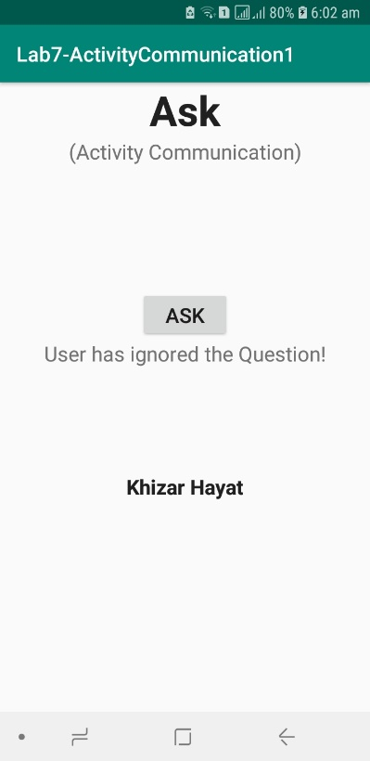

**Task#2:** Create an application which can manipulate a Clock object having hours, minutes and seconds as integer attributes. Your application must have only two activities as follows:

* 1. ***ClockActivity***

Shows the clock contents and the gives field selection by radio buttons for update. Creates new Clock object, displays it and send it to UpdateActivity for update.

* 1. ***UpdateActivity***

Gets data for the selected field. Saves the field in the object and send back object to ClockActivity.

You must pass whole object from activity to activity. Remember that your class must implement Serializable interface.

<<Serializable>>

Clock

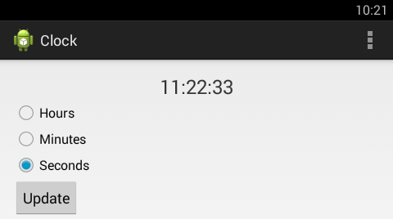

ClockActivity: Having selection of fields

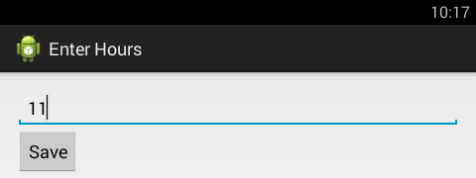

UpdateActivity: After selecting hours

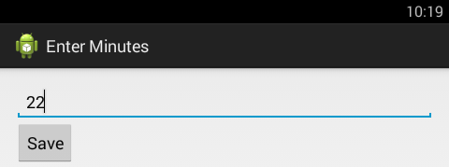

UpdateActivity: After selecting minutes

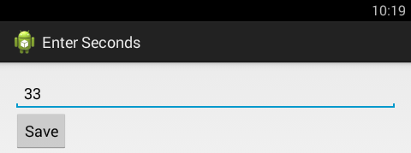

UpdateActivity: After selecting seconds

**Solution:**

**XML:**

**(Main)**

<?xml version="1.0" encoding="utf-8"?>  
<RelativeLayout xmlns:android="http://schemas.android.com/apk/res/android"  
  
 xmlns:tools="http://schemas.android.com/tools"  
 android:layout_width="match_parent"  
 android:layout_height="match_parent"  
 tools:context=".MainActivity">  
  
 <LinearLayout  
 android:layout_width="match_parent"  
 android:layout_height="match_parent"  
 android:weightSum="10"  
 android:orientation="vertical">  
  
 <TextView  
 android:id="@+id/title_text_view"  
 android:layout_width="match_parent"  
 android:layout_height="wrap_content"  
 android:text="Clock"  
 android:textSize="40dp"  
 android:textAppearance="?android:textAppearanceLarge"  
 android:textStyle="bold"  
 android:textAlignment="center"/>  
 <TextView  
 android:layout_width="match_parent"  
 android:layout_height="wrap_content"  
 android:layout_weight="0.5"  
 android:text="(Using Serialization)"  
 android:textAlignment="center"  
 android:textSize="20dp"/>  
 <TextView  
 android:layout_width="match_parent"  
 android:layout_height="wrap_content"  
 android:layout_weight="1"/>  
  
 <TextClock  
 android:layout_width="match_parent"  
 android:layout_height="wrap_content"  
 android:textSize="40dp"  
 android:layout_weight="1"  
 android:id="@+id/clock_time"  
 android:gravity="center" />  
   
 <RadioGroup  
 android:layout_width="match_parent"  
 android:layout_height="wrap_content">  
  
 <RadioButton  
 android:layout_width="match_parent"  
 android:layout_height="wrap_content"  
 android:text="Hours"  
 android:id="@+id/radio_hh"  
 android:textSize="20dp"/>  
 <RadioButton  
 android:layout_width="match_parent"  
 android:layout_height="wrap_content"  
 android:text="Minutes"  
 android:id="@+id/radio_mm"  
 android:textSize="20dp"/>  
 <RadioButton  
 android:layout_width="match_parent"  
 android:layout_height="wrap_content"  
 android:text="Seconds"  
 android:id="@+id/radio_ss"  
 android:textSize="20dp"/>  
  
 </RadioGroup>  
  
 <Button  
 android:id="@+id/btnUpdate"  
 android:layout_width="wrap_content"  
 android:layout_height="wrap_content"  
 android:textAlignment="center"  
 android:layout_gravity="center"  
 android:textSize="20dp"  
 android:onClick="onClick"  
 android:text="Update" />  
  
 <TextView  
  
 android:layout_width="match_parent"  
 android:layout_height="wrap_content"  
 android:text="Khizar Hayat"  
 android:textSize="20dp"  
 android:textAppearance="?android:textAppearanceLarge"  
 android:textStyle="bold"  
 android:gravity="center"  
 android:textAlignment="center"  
 android:layout_weight="4"/>  
  
 </LinearLayout>  
  
</RelativeLayout>

**(Update)**

<?xml version="1.0" encoding="utf-8"?>  
<RelativeLayout xmlns:android="http://schemas.android.com/apk/res/android"  
  
 xmlns:tools="http://schemas.android.com/tools"  
 android:layout_width="match_parent"  
 android:layout_height="match_parent"  
 tools:context=".MainActivity">  
  
 <LinearLayout  
 android:layout_width="match_parent"  
 android:layout_height="match_parent"  
 android:weightSum="10"  
 android:orientation="vertical">  
  
 <TextView  
 android:id="@+id/title_text_view"  
 android:layout_width="match_parent"  
 android:layout_height="wrap_content"  
 android:text="Clock"  
 android:textSize="40dp"  
 android:textAppearance="?android:textAppearanceLarge"  
 android:textStyle="bold"  
 android:textAlignment="center"/>  
 <TextView  
 android:layout_width="match_parent"  
 android:layout_height="wrap_content"  
 android:layout_weight="0.5"  
 android:text="(Update)"  
 android:id="@+id/updateText"  
 android:textAlignment="center"  
 android:textSize="20dp"/>  
 <TextView  
 android:layout_width="match_parent"  
 android:layout_height="wrap_content"  
 android:layout_weight="2"/>  
  
 <EditText  
 android:layout_width="match_parent"  
 android:layout_height="wrap_content"  
 android:id="@+id/edittext"  
 android:hint="Update Hours"/>  
 <Button  
 android:id="@+id/btnSave"  
 android:layout_width="wrap_content"  
 android:layout_height="wrap_content"  
 android:textAlignment="center"  
 android:layout_gravity="center"  
 android:textSize="20dp"  
 android:text="Save" />  
  
 <TextView  
 android:layout_width="match_parent"  
 android:layout_height="wrap_content"  
 android:text="Khizar Hayat"  
 android:textSize="20dp"  
 android:textAppearance="?android:textAppearanceLarge"  
 android:textStyle="bold"  
 android:gravity="center"  
 android:textAlignment="center"  
 android:layout_weight="4"/>  
   
 </LinearLayout>  
  
</RelativeLayout>

**(Update-1)**

<?xml version="1.0" encoding="utf-8"?>  
<RelativeLayout xmlns:android="http://schemas.android.com/apk/res/android"  
  
 xmlns:tools="http://schemas.android.com/tools"  
 android:layout_width="match_parent"  
 android:layout_height="match_parent"  
 tools:context=".MainActivity">  
  
 <LinearLayout  
 android:layout_width="match_parent"  
 android:layout_height="match_parent"  
 android:weightSum="10"  
 android:orientation="vertical">  
  
 <TextView  
 android:id="@+id/title_text_view"  
 android:layout_width="match_parent"  
 android:layout_height="wrap_content"  
 android:text="Clock"  
 android:textSize="40dp"  
 android:textAppearance="?android:textAppearanceLarge"  
 android:textStyle="bold"  
 android:textAlignment="center"/>  
 <TextView  
 android:layout_width="match_parent"  
 android:layout_height="wrap_content"  
 android:layout_weight="0.5"  
 android:text="(Update)"  
 android:id="@+id/updateText"  
 android:textAlignment="center"  
 android:textSize="20dp"/>  
 <TextView  
 android:layout_width="match_parent"  
 android:layout_height="wrap_content"  
 android:layout_weight="2"/>  
  
 <EditText  
 android:layout_width="match_parent"  
 android:layout_height="wrap_content"  
 android:id="@+id/edittext"  
 android:hint="Update Minutes"/>  
 <Button  
 android:id="@+id/btnSave"  
 android:layout_width="wrap_content"  
 android:layout_height="wrap_content"  
 android:textAlignment="center"  
 android:layout_gravity="center"  
 android:textSize="20dp"  
 android:text="Save" />  
  
 <TextView  
  
 android:layout_width="match_parent"  
 android:layout_height="wrap_content"  
 android:text="Khizar Hayat"  
 android:textSize="20dp"  
 android:textAppearance="?android:textAppearanceLarge"  
 android:textStyle="bold"  
 android:gravity="center"  
 android:textAlignment="center"  
 android:layout_weight="4"/>  
 </LinearLayout>  
  
</RelativeLayout>

**(Update-2)**

<?xml version="1.0" encoding="utf-8"?>  
<RelativeLayout xmlns:android="http://schemas.android.com/apk/res/android"  
  
 xmlns:tools="http://schemas.android.com/tools"  
 android:layout_width="match_parent"  
 android:layout_height="match_parent"  
 tools:context=".MainActivity">  
  
 <LinearLayout  
 android:layout_width="match_parent"  
 android:layout_height="match_parent"  
 android:weightSum="10"  
 android:orientation="vertical">  
  
 <TextView  
 android:id="@+id/title_text_view"  
 android:layout_width="match_parent"  
 android:layout_height="wrap_content"  
 android:text="Clock"  
 android:textSize="40dp"  
 android:textAppearance="?android:textAppearanceLarge"  
 android:textStyle="bold"  
 android:textAlignment="center"/>  
 <TextView  
 android:layout_width="match_parent"  
 android:layout_height="wrap_content"  
 android:layout_weight="0.5"  
 android:text="(Update)"  
 android:id="@+id/updateText"  
 android:textAlignment="center"  
 android:textSize="20dp"/>  
 <TextView  
 android:layout_width="match_parent"  
 android:layout_height="wrap_content"  
 android:layout_weight="2"/>  
  
 <EditText  
 android:layout_width="match_parent"  
 android:layout_height="wrap_content"  
 android:id="@+id/edittext"  
 android:hint="Update Seconds"/>  
 <Button  
 android:id="@+id/btnSave"  
 android:layout_width="wrap_content"  
 android:layout_height="wrap_content"  
 android:textAlignment="center"  
 android:layout_gravity="center"  
 android:textSize="20dp"  
 android:text="Save" />  
  
 <TextView  
  
 android:layout_width="match_parent"  
 android:layout_height="wrap_content"  
 android:text="Khizar Hayat"  
 android:textSize="20dp"  
 android:textAppearance="?android:textAppearanceLarge"  
 android:textStyle="bold"  
 android:gravity="center"  
 android:textAlignment="center"  
 android:layout_weight="4"/>  
 </LinearLayout>  
</RelativeLayout>

**JAVA:**

**(Main)**

public class MainActivity extends AppCompatActivity{  
  
 RadioButton hradio,mradio,sradio, radioButton;  
 Button update;  
 TextClock time;  
 RadioGroup radioGroup;  
   
 @Override  
 protected void onCreate(Bundle savedInstanceState) {  
 super.onCreate(savedInstanceState);  
 setContentView(R.layout.activity_main);  
  
 hradio = findViewById(R.id.radio_hh);  
 mradio = findViewById(R.id.radio_mm);  
 sradio = findViewById(R.id.radio_ss);  
 time = findViewById(R.id.clock_time);  
 update = findViewById(R.id.btnUpdate);  
 time.setFormat12Hour("kk:mm:ss");  
  
 if(hradio.isChecked()){  
 mradio.setChecked(false);  
 sradio.setChecked(false);  
 }  
 else if(mradio.isChecked()){  
 hradio.setChecked(false);  
 sradio.setChecked(false);  
 }  
 else if(sradio.isChecked()){  
 hradio.setChecked(false);  
 mradio.setChecked(false);  
 }  
   
 update.setOnClickListener(new View.OnClickListener() {  
 @Override  
 public void onClick(View v) {  
  
 if(hradio.isChecked()){  
 Intent in = new Intent(MainActivity.this, Update.class);  
 String hstring = hradio.getText().toString();  
 String mstring = mradio.getText().toString();  
 String sstring = sradio.getText().toString();  
 clock ctime = new clock(hstring,mstring,sstring);  
 in.putExtra("object", ctime);  
 startActivity(in);  
 }  
  
 else if(mradio.isChecked()){  
 Intent in = new Intent(MainActivity.this, Update1.class);  
 String hstring = hradio.getText().toString();  
 String mstring = mradio.getText().toString();  
 String sstring = sradio.getText().toString();  
 clock ctime = new clock(hstring,mstring,sstring);  
 in.putExtra("object", ctime);  
 startActivity(in);  
 }  
  
 else if(sradio.isChecked()){  
 Intent in = new Intent(MainActivity.this, Update2.class);  
 String hstring = hradio.getText().toString();  
 String mstring = mradio.getText().toString();  
 String sstring = sradio.getText().toString();  
 clock ctime = new clock(hstring,mstring,sstring);  
 in.putExtra("object", ctime);  
 startActivity(in);  
 }  
 else {  
 Toast.makeText(getBaseContext(),"No option selected",Toast.LENGTH_SHORT).show();  
 }  
 }  
 });  
 }  
}

**(Update)**

public class Update extends AppCompatActivity {  
  
 @Override  
 protected void onCreate(Bundle savedInstanceState) {  
 super.onCreate(savedInstanceState);  
 setContentView(R.layout.activity_update);  
  
 Button btn = (Button) findViewById(R.id.btnSave);  
 final EditText edit = (EditText) findViewById(R.id.edittext);  
 TextView txt = (TextView) findViewById(R.id.updateText);  
 Intent in = getIntent();  
 Bundle bun = in.getExtras();  
 clock ctime = (clock) bun.getSerializable("object");  
 txt.setText(ctime.getHtime());  
  
 DateFormat df = new SimpleDateFormat("HH");  
 String date = df.format(Calendar.getInstance().getTime());  
 edit.setText(date);  
   
 btn.setOnClickListener(new View.OnClickListener() {  
 @Override  
 public void onClick(View v) {  
 Toast.makeText(getBaseContext(),"Updates Saved",Toast.LENGTH_SHORT).show();  
 }  
 });  
 }  
}

**(Update-1)**

public class Update1 extends AppCompatActivity {  
  
 @Override  
 protected void onCreate(Bundle savedInstanceState) {  
 super.onCreate(savedInstanceState);  
 setContentView(R.layout.activity_update1);  
  
 Button btn = (Button) findViewById(R.id.btnSave);  
 EditText edit = (EditText)findViewById(R.id.edittext);  
 TextView txt = (TextView)findViewById(R.id.updateText);  
 Intent in = getIntent();  
 Bundle bun = in.getExtras();  
 clock ctime = (clock) bun.getSerializable("object");  
 txt.setText(ctime.getMtime());  
  
 DateFormat df = new SimpleDateFormat("mm");  
 String date = df.format(Calendar.getInstance().getTime());  
 edit.setText(date);  
  
 btn.setOnClickListener(new View.OnClickListener() {  
 @Override  
 public void onClick(View v) {  
 Toast.makeText(getBaseContext(),"Updates Saved",Toast.LENGTH_SHORT).show();  
 }  
 });  
 }  
}

**(Update-2)**

public class Update2 extends AppCompatActivity {  
  
 @Override  
 protected void onCreate(Bundle savedInstanceState) {  
 super.onCreate(savedInstanceState);  
 setContentView(R.layout.activity_update2);  
  
  
 Button btn = (Button) findViewById(R.id.btnSave);  
 EditText edit = (EditText)findViewById(R.id.edittext);  
 TextView txt = (TextView)findViewById(R.id.updateText);  
 Intent in = getIntent();  
 Bundle bun = in.getExtras();  
 clock ctime = (clock) bun.getSerializable("object");  
 txt.setText(ctime.getStime());  
 DateFormat df = new SimpleDateFormat("ss");  
 String date = df.format(Calendar.getInstance().getTime());  
 edit.setText(date);  
   
 btn.setOnClickListener(new View.OnClickListener() {  
 @Override  
 public void onClick(View v) {  
 Toast.makeText(getBaseContext(),"Updates Saved",Toast.LENGTH_SHORT).show();  
 }  
 });  
 }  
}

**(Clock)**

package com.example.lab7_activitycommunication2;  
import java.io.Serializable;  
  
public class clock implements Serializable {  
 public void setHtime(String htime) {  
 this.htime = htime;  
 }  
 public void setMtime(String mtime) {  
 this.mtime = mtime;  
 }  
 public void setStime(String stime) {  
 this.stime = stime;  
 }  
 public clock(String htime, String mtime, String stime) {  
 this.htime = htime;  
 this.mtime = mtime;  
 this.stime = stime;  
 }  
 private String htime;  
 public String getHtime() {  
 return htime;  
 }  
 public String getMtime() {  
 return mtime;  
 }  
 public String getStime() {  
 return stime;  
 }  
 private String mtime;  
 private String stime;  
}

**Output:**

